**More on strings**

https://www.youtube.com/watch?v=nkKeA74p3RY&list=PLAE85DE8440AA6B83&index=72

#include "stdafx.h"

#include <iostream>

#include <string>

using namespace std;

int main()

{

string text="This is a text and this and this are nothing special";

cout << text.substr(10, 4) << endl<<endl; //(index, number of chars)

cout << text.find("this")<<endl;

cout << text.find("This") << endl; //Letter capital matters here

cout << text.rfind("this") << endl<<endl; //Finds in reverse. Starts from the right

string one = "apples";

string two = "bananas";

cout << one <<", "<< two << endl;

one.swap(two);

cout << one <<", "<< two << endl;

}

**Result:**

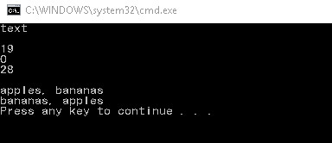

**Important notes:**

* In most cases, whether a letter is capital or not matters
* When declaring string, you can either do “string text=”hi”;” or “string text(“hi”);”

#include "stdafx.h"

#include <iostream>

#include <string>

using namespace std;

int main()

{

string s1 = "Hi my name is Ken and I love weird stuff";

cout << s1 << endl;

s1.erase(17); //Starts erasing from index 17

cout << s1 << endl<<endl;

s1.replace(14, 3, "Johnny Sins"); //Replace takes 3 parameters

cout << s1 << endl; //(from which index, how many chars, with which string)

s1.insert(5, " awesome"); //With this, you can insert any string in any index

cout << s1 << endl;

}

**Result:**

